Data Structures and Algorithms Assessment

Report

Explanation of program (8)

I was tasked to design and implement a program that performs a predictive text function, similar to that found in modern mobile phones. The specification stated my program must be able to take a text file of words, read them into a suitable data structure and perform searches on this data structure in order to fulfil the predictive text functionality.

**Describe what the program does:**

My program contains predictive text functionality, it operates by searching on a given prefix to a word that is entered in by the user. Upon pressing the Tab key the program returns a word which the user can decide to accept or they can just continue typing.

**Describe how the program operates:**

The first thing my program does is load the text file I am going to read into local memory using Windows file loading functions which I have tested work in the Lab(TEST). Next my program increments character by character through the loaded text file and uses these characters to populate a Trie data structure

**Overall structure of the program(Diagrams):**

**What I would have done differently given time:**

This would include these main things:

* Loading a text file into the program
* Going through the text file and filling a data structure with the words found in the text file
* Dealing with user keyboard input
* Searching to Autocomplete a word that the user has started typing when the press a certain key
* Display possible options to autocomplete
* Autocompleting the users word

TODO go through all these points in more detail

Explanation of data structure chosen and discussion of alternatives (10)

For this assignment I eventually decided to use a Trie data structure. A Trie has the structure:

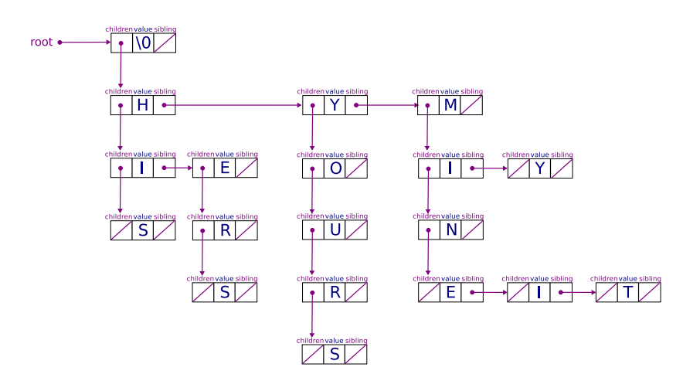

Testing strategy (2)